**ASSIGNMENT 4**

**QUESTION 1:**

% To plot graph for true values

N = 1000; % total number of time steps

true_pop = zeros(N+1,1);

true_food = zeros(N+1,1);

% entering the initial states

dt = 1;

time = [1:dt:11];

true_pop(1) = 650;

true_food(1) = 250;

for i=2:N+1

true_pop(i,1) = (true_pop(i-1,1)/2)+(2*true_food(i-1,1));

true_food(i,1) = true_food(i-1,1);

end

% to calculate the estimated value= zeros(N+1,1);

plus_state = zeros(2,N+1);

minus_state = zeros(2,N+1);

gain= zeros(2,N+1);

%error= zeros(2,N);

F = [1 0; 2 0.5];

L = [1 0 ;0 0];

Q = [10 0;0 0];

Q_tilde = L'*Q*L;

R = [10];

H = [0 1];

P_plus = [200 0;0 500];

P_minus = [0 0;0 0];

I = [1 0;0 1];

plus_state(1,1) = 200;

plus_state(2,1) = 600;

std_1 = zeros(N+1,1);

std_2 = zeros(N+1,1);

for j= 2:N+1

P_minus = F*P_plus*F'+Q_tilde;

value = (inv(H*P_minus*H'+R));

gain(:,j) = P_minus*H'*value;

minus_state(:,j) = F*plus_state(:,j-1);

plus_state(:,j) = minus_state(:,j) + gain(:,j)*(true_pop(j,:)-H*minus_state(:,j));

P_plus= (I-gain(:,j)*H)*P_minus;

std_1(j,1)= sqrt(P_plus(1,1));

std_2(j,1)= sqrt(P_plus(2,2));

end

P_plus

% To plot population comparison

set(gcf,'color','w');

plot(time,true_pop(:,1));

hold on;

plot(time,plus_state(2,:));

hold off;

% to plot food supply comparison

% plot(time,true_food(:,1));

% hold on;

% plot(time,plus_state(1,:));

% hold off;

% To plot the standard deviations

% plot(time,std_1(:,1));

%plot(time,std_2(:,1));

% % to plot gain as a function of time

% plot(time,gain(1,:)) % food

% plot(time,gain(2,:)) % population

% to calculate std deviation as a function of time

GRAPH 1:

True population and expected population:

X axis : Time step Y axis : Population

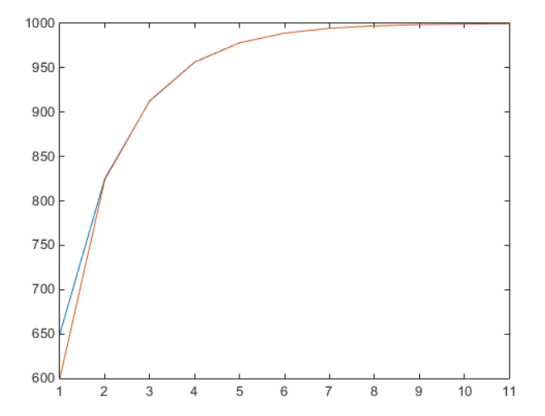

GRAPH 2:

TRUE FOOD SUPPLY AND ESTIMATED FOOD SUPPLY:

X AXIS : TIME STEP Y AXIS : FOOD SUPPLY

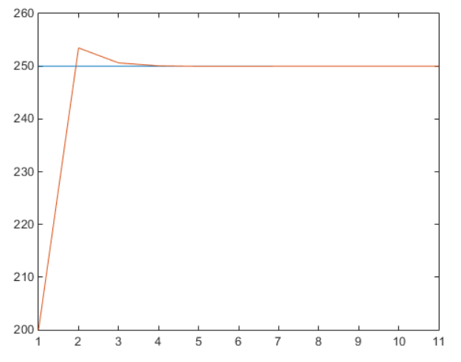

STANDARD DEVIATION OF FOOD ESTIMATION ERROR

X : TIME SERIES Y= STD OF ERROR IN FOOD ESTIMATION

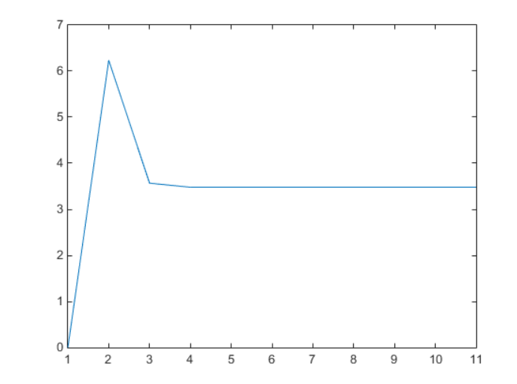

STANDARD DEVIATION OF POPULATION ESTIMATION ERROR

X : TIME SERIES Y= STD OF ERROR IN POPULATION ESTIMATION

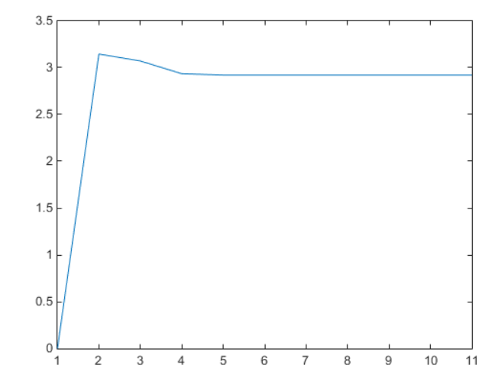

GAIN FOR FOOD: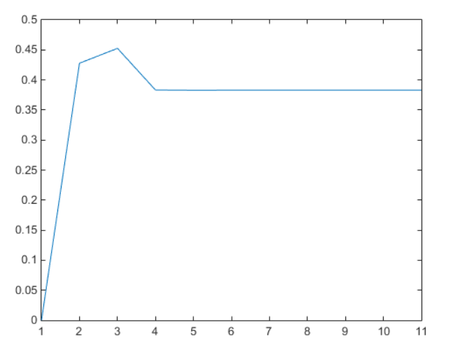

GAIN FOR POPULATION

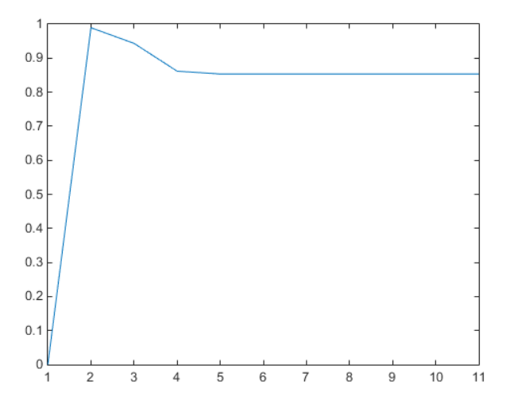

QUESTION 3:

A = [0 2; -1 -3];

H = [1 0];

dt = 1/10;

time = [0:dt:2];

N = 20;

R =1/10;

Q = [1 0; 0 1];

L = [0 1];

plus_state = zeros(2,N);

minus_state = zeros(2,N);

gain= zeros(2,N);

P_plus = [0 0;0 0];

F = [1 0.2; -0.1 0.7];

Q_c = L*Q*L';

var_1 = zeros(N+1,1);

var_2 = zeros(N+1,1);

for j= 2:N

Q_tilde = [0.2*time(j)^2 0.2*time(j)-0.6*(time(j)^2);0.2*time(j)-0.6*(time(j)^2) 0.1+0.9*time(j)^2-0.2*time(j)];

P_minus = F*P_plus*F'+Q_tilde;

value = (inv(H*P_minus*H'+R));

gain(:,j) = P_minus*H'*value;

%minus_state(:,j) = F*plus_state(:,j-1);

%error(1,j-1) = true_pop(j,:)-H*minus_state(:,j);

%plus_state(2,j) = minus_state(2,j) + gain(2,j)*(0-H*minus_state(1,j));

P_plus= (I-gain(:,j)*H)*P_minus;

var_1(j,1)= (P_plus(1,1));

var_2(j,1)= (P_plus(2,2));

var_1(j,2)= (P_minus(1,1));

var_2(j,2)= (P_minus(2,2));

end

set(gcf,'color','w');

plot(time,var_2(:,1),'r');

hold on;

plot(time,var_2(:,2),'b');

hold off;

GRAPH:

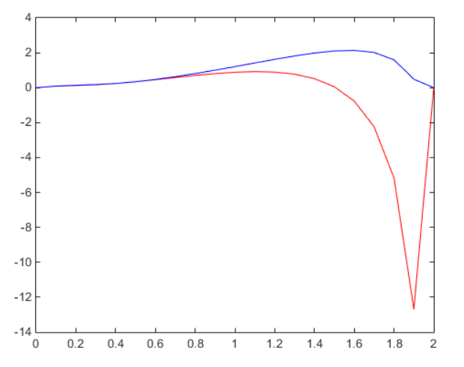

QUESTION 5:

F = [1 0;2 0.5];

L = [1 0;0 0];

H = [0 1];

Q = [10 0;0 0];

%F = A;

% (4) Initial Conditions and Noise Matrices

x_0 = [200;600];

P_0 = [200 0;0 500];

R = [10];

LQL = L'*Q*L;

% (5) Forward Propagation of Covariance

cov_f_p = zeros(drl,4); % Forward + covariance history

cov_f_m = zeros(drl,4); % Forward - covariance history

Pf = P_0;

cov_f_p(1,:) = [Pf(1,1) Pf(1,2) Pf(2,1) Pf(2,2)];

cov_f_m(1,:) = [Pf(1,1) Pf(1,2) Pf(2,1) Pf(2,2)];

for k=2:drl

Pf = F*Pf*F' + LQL;

cov_f_m(k,:) = [Pf(1,1) Pf(1,2) Pf(2,1) Pf(2,2)];

K = Pf*H'*inv(H*Pf*H' + R);

Pf = (eye(2) - K*H)*Pf;

cov_f_p(k,:) = [Pf(1,1) Pf(1,2) Pf(2,1) Pf(2,2)];

end

%% (6) Backward Propagation of Covariance

F_b = inv(F);

LQL_b = F_b*LQL*F_b';

cov_b_p = zeros(drl,4); % Backward covariance history

Pb = 10000*P_0; % Not quite infinity but large enough

I = [0 0;0 0]; % For Homework fix this so that you are

% using an information matrix

cov_b_p(end,:) = [Pb(1,1) Pb(1,2) Pb(2,1) Pb(2,2)];

eps = 0.0001;

for k=drl-1:-1:1

I = I + H'*pinv(R)*H;

Pb = pinv(I);

inter_1 = F_b*pinv(I)*F_b';

inter_2 = F_b*LQL*F_b';

I = pinv(inter_1+inter_2);

% Pb = pinv(I);

% Pb = F_b*Pb*F_b' + LQL_b;

% K = Pb*H'*inv(H*Pb*H' + R);

% Pb = (eye(2) - K*H)*Pb;

cov_b_p(k,:) = [Pb(1,1) Pb(1,2) Pb(2,1) Pb(2,2)];

end

%% (7) RTS Backward Propagation of Covariance

cov_s = zeros(drl,4); % Smoother covariance history

Ps = Pf;

cov_s(end,:) = [Ps(1,1) Ps(1,2) Ps(2,1) Ps(2,2)];

for k=(drl-1):-1:1

Pf_kp = [cov_f_p(k,1) cov_f_p(k,2);cov_f_p(k,3) cov_f_p(k,4)];

Pf_k1m = [cov_f_m(k+1,1) cov_f_m(k+1,2);cov_f_m(k+1,3) cov_f_m(k+1,4)];

K = Pf_kp*F'*inv(Pf_k1m);

Ps = Pf_kp - K*(Pf_k1m - Ps)*K';

cov_s(k,:) = [Ps(1,1) Ps(1,2) Ps(2,1) Ps(2,2)];

end

figure(gcf)

subplot(121)

h1f = semilogy(t,cov_f_p(:,1),'b-');hold on;grid on;

h1b = semilogy(t,cov_b_p(:,1),'r-');

h1s = semilogy(t,cov_s(:,1),'g*');

legend('P_f','P_b','P_{RTS}')

set(h1f,'LineWidth',2);set(h1b,'LineWidth',2);set(h1s,'LineWidth',2);

xlabel('Time (sec)');ylabel('P_{11}');

subplot(122)

h2f = semilogy(t,cov_f_p(:,4),'b-');hold on;grid on;

h2b = semilogy(t,cov_b_p(:,4),'r-');

h2s = semilogy(t,cov_s(:,4),'g*');

set(h2f,'LineWidth',2);set(h2b,'LineWidth',2);set(h2s,'LineWidth',2);

xlabel('Time (sec)');ylabel('P_{22}');

GRAPH:

